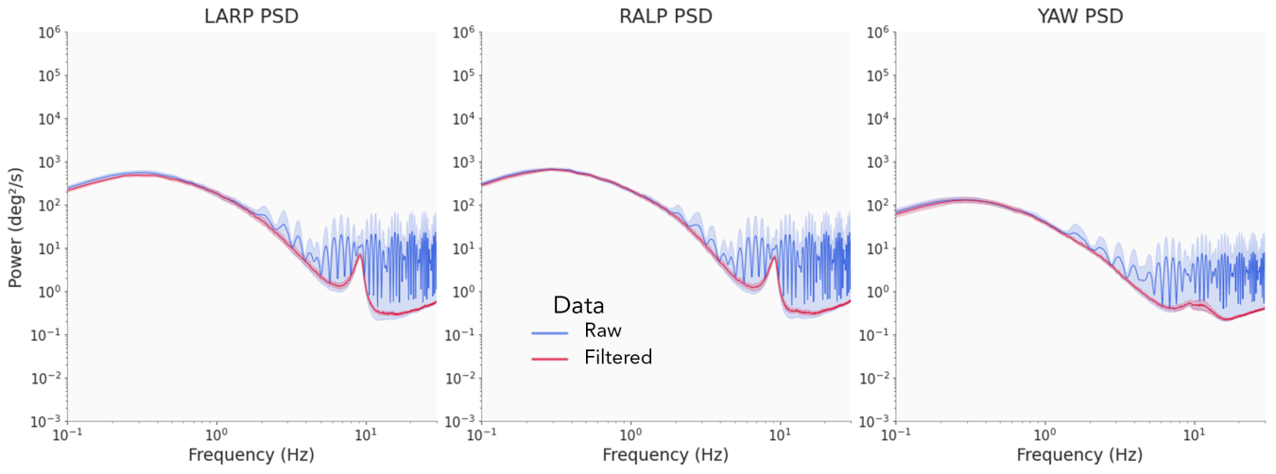**Sample quality**

Supplementary Figure 1: Population-averaged power spectra of the head-velocity in the LARP, RALP and YAW planes with corresponding 95% confidence interval (shaded areas). Blue: raw data, red: filtered data, where samples associated with a quality value below 0.5 were discarded.

Each data sample measured with the HObIT had an associated quality value. This value is an indication of how ‘confident’ the sensor is that this measurement is correct. Even though numerous factors can affect the quality of a sample, we believe that the physiological characteristics of the individual whose head is being tracked are the most predominant, notably their height and their posture. The subjective camera that tracks the fiducial has an optimal focus range, hence differences in height and posture may lead to better or worst recordings in terms of quality. Apropos of that, the overall quality of the recordings varies greatly among pilots in the manual navigation task. We found that lower quality samples were in fact artifacts that were detrimental to compute a decent power spectrum. Experimentally, we chose to set a threshold on the minimum quality required for a sampled to be considered correct and discarded the rest. The results presented in this paper included that ‘filtering’ or ‘denoising’ step, with a threshold set to 0.5. Supplementary Figure 1 shows the superposition of the power spectra obtained before and after the filtering. We can see that not filtering the low-quality samples limits the interpretability of our results. While the blue and red curves follow the same shape in the low frequency range (0-3 Hz), many artifacts pollute the higher frequencies when using the raw data.